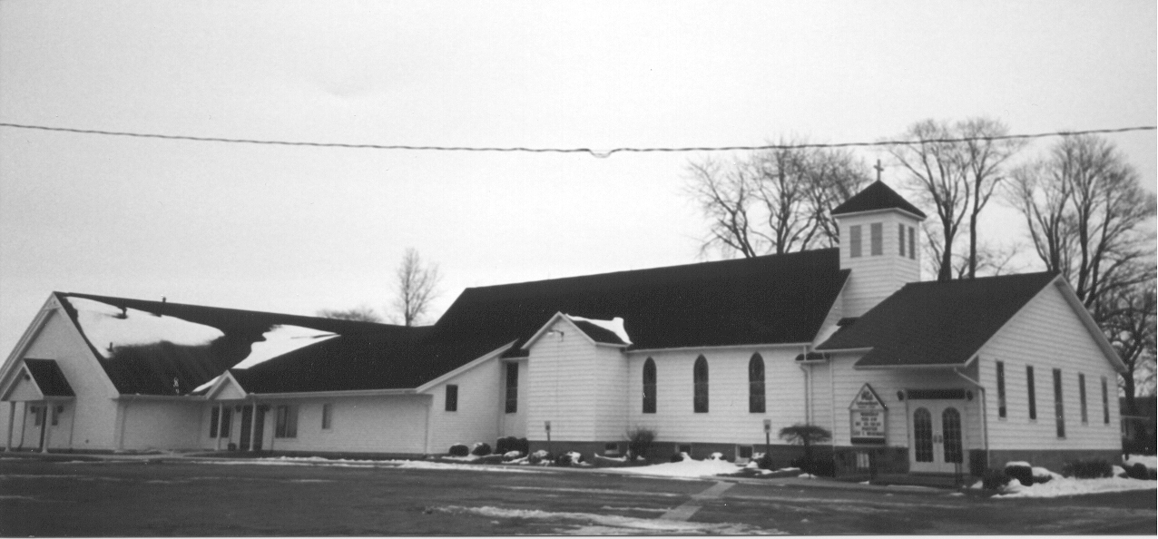St. Paul's
" E p i s t l e s"
December 2020 Volume 37 No. 2


O come, O come, Emmanuel, and ransom captive Israel. The Advent hymn is a prayer - it is our prayer. In this prayer we beg for God to come and to be “God with us” (which is what Emmanuel means.) We cry out for Him to be among us, to dwell with us, to come and do for us what we could never do: ransom us, make the payment for us, be the total sum of all our hope for release from the captivity of our broken selves and our broken world.

O come, Emmanuel, rend the heavens and come down. Visit Your people who mourn in lowly exile here. Disperse the gloomy clouds of night and be Thyself our King of Peace. Hear our prayer, O Lord. Let our cry come to you.

He hears our prayer. He comes. In the fullness of time, God came to dwell with us as He deigned to be born of the Virgin. True God, Emmanuel, desired to become manifest in the flesh to be “God with us.” Our prayer is answered as Jesus goes to the manger and then to the cross to be our ransom.

O, what an Advent, what a coming! Almighty God binds Himself to us, His creatures, in the most glorious way. He sees the great need that we live in and comes! Our brokenness will not last forever, our mourning will not last a lifetime. Peace has entered into our world for us captives. Rejoice! Rejoice!

Our Advent prayer has been answered and is still being answered. Our Lord still comes! Placing Himself into our midst as a rose among thorns that His sweet fragrance lifts up our heads to see the Wisdom of God dwelling in His Holy Word where we place all of our hope, for Christ comes to anchor us there. To calm our anxieties and give direction to our wavering hearts, He comes! To be mercy for us, to be comfort for us, to be the light in our darkness, He comes!

As you sing the Advent hymns and the hymns of Christmas, you are praying and confessing the wondrous deeds of the Savior of the nations who dwells with us. The Lord hears the prayers of His children, ransoms us, and we can’t help but sing. Rejoice! Christ comes!

A blessed Advent and Merry Christmas,

Pastor Suggitt

It’s LUTHERAN WITNESS time!

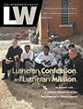
It's time to re-subscribe or subscribe to THE LUTHERAN WITNESS at a discounted rate. The Lutheran Witness is the official periodical of The Lutheran Church—Missouri Synod and is published 11 times a year. It provides Missouri Synod laypeople with stories and information that complement congregational life, foster personal growth in faith, and help interpret the contemporary world from a Lutheran Christian perspective.

Subscriptions ordered through your church will include the Michigan In Touch supplement. The new subscription year doesn't begin until March 2021.

Payment for subscriptions should be made directly to your St. Paul Lutheran Church. Please place your payment in an envelope including your name and mailing address, and deposit in the basket on the desk in the office by DECEMBER 6th to take advantage of a discounted District rate of $11.60/year.

LIFE QUOTES

“This Christmas, let us continue to pray for mothers who are afraid and aren’t sure where to turn when they discover they are unexpectedly pregnant. Let us pray that, like Mary, they may find the courage to bring life into the world.”

Right to Life of Michigan
A Life Quote from Lutherans For Life • www.lutheransforlife.org

HIGHER THINGS CONFERENCE 2021

FORGIVEN
“IF YOU FORGIVE ANYONE HIS SINS, THEY ARE FORGIVEN.”
(JOHN 20:23)


“I forgive you.” Powerful words. Jesus words. His words for you through “The minister whom Christ has sent.” (LSB 614:5) Also His words for others through you. These words won’t just change your summer or transform your daily life as a baptized child of God. With these three words, Jesus changes your eternity.

This conference is aimed at Jr. High through High School students. Through break-out sessions, fun activities, and worship, our children will hear great theology and meet other Lutherans their age at this distinctly Lutheran gathering. Many youth from other churches in the Thumb Area have been attending this conference yearly and see it as a highlight of their summer.

See Pastor Suggitt to sign-up or for more information.

CALVIN UNIVERSITY, GRAND RAPIDS, MI
JULY 20-23

Registration opens November 1.

HIGHER THINGS - DARE TO BE LUTHERAN
higherthings.org


The regular meeting of St. Paul Ladies Aid was called to order by President Ruth Fluegge immediately following our worship service on Sunday, November 1, 2020.

The meeting began with a devotion based on Ephesians 3:1 thru 3. The topic was stewardship. ‘The greatest and ONLY gift that our Lord has given to us to steward is the Gospel of Jesus Christ. If your resources are used to help your friends, family, congregation and community to better understand the Gospel, you are a faithful steward.”

Fourteen members answered roll call. Two thank you notes were read from Kaitlyn Reehl for the confirmation prayers and blessings as well as her gift and from Melissa Deming for our donation to the Thumb Blessing Boxes.

The secretary’s report from the October 4, 2020 meeting was read. Ruth Kumaus gave the treasurer’s report. The bank statement at the end of October showed a balance of $19,272. in the checking account; savings account – $11,278; petty cash – $139.75.

Old Business:

- Profits from our ‘bazaar’ totaled a bit over $4,000.
- Discussion was held on how we should use the remaining canned goods – possibly gift baskets for shut-ins during the Christmas season.

New Business:

- Election of Officers was held. They will remain the same.
President: Ruth Fluegge
Vice President: Janet Truemner
Secretary: Sandy Salcido
Treasurer: Ruth Kumaus

- Our treasurer gave us a breakdown on our finances for the coming year. Discussion was held on what our charitable donations would be for 2020. Several suggestions were made – St. Paul’s Seminary student; Pastor Fritch, the Alaska minister; Orphan Grain Train. Members should think about donations and come with suggestions at our December meeting.

- Several ladies have volunteered to make some goodies for the Christmas season, a Pre-Order Christmas Goodies Sale with handmade chocolates, braided coffeecakes, sweet breads, as well as peanut brittle and peanut butter fudge. Order forms were enclosed with the November newsletter and posted in the narthex. Deadline for orders is November 29th with delivery on December 12th.

The meeting closed with singing the doxology as saying the Lord’s Prayer.

Respectively submitted,

Sandy Salcido, Secretary

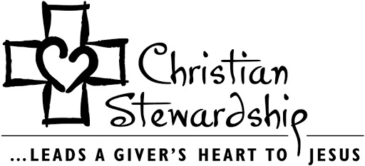



SOUP AND SANDWICH SALE

It’s getting’ cold outside so the Youth Group is having another pre-order sale. This time we are raising money to pay for the Higher Things Youth Conference that’s scheduled for July 2021.

We will be selling a different assortment of soups including:
Chicken Wild Rice
Broccoli Cheese
Meaty Chili
Navy Bean with Ham
French Spring

The sandwich spreads will come in 8 oz. and 16 oz. containers. Varieties will include:
Ground Bologna
Chicken Salad with Cranberries
Chicken without Cranberries

Orders are due by December 27th for pickup on Saturday, January 16th from 6:00 p.m. – 7:00 p.m. or Sunday, January 17th immediately after church. Please see attached order form or find extra copies in the North narthex.

Orders and payments can be placed in the basket on the table in the North narthex (Cash or Checks (make out to St Paul Lutheran Church with Youth Group on MEMO line). THANK YOU SO MUCH FOR YOUR SUPPORT!

Youth group will package and sort orders on January 16th from 4:00 p.m. – 6:00 pm.

Advent Vespers
(We are refraining from the Advent suppers this year.)

December 2 @ 7:00 p.m.

Good Shepherd, Caseville

December 9 @ 7:00 p.m.

St. Paul, Linkville

December 16 @ 7:00 p.m.

Good Shepherd, Caseville

St. Paul's "Epistles" is published monthly by St. Paul Evangelical Lutheran Church, 7292 Kilmanagh Road, Pigeon, MI, 48755.

Pastor: Rev. Christopher Suggitt

Church & Office Phone: (989) 453-2271
Pastor Suggitt’s Cell Phone: (989) 551-3976

Church Email: lvlspaul40@gmail.com
Secretary’s Email: salcido.sandy8@gmail.com

Sunday Worship: 8:30 a.m.
Sunday School: 9:30 a.m.

YOUTH GROUP PREORDER SOUP AND SANDWICH SALE
ORDER FORM

NAME _______________________________________

 | CHICKEN WILD RICE | BROCCOLI  CHEESE | MEATY  CHILI |  | NAVY BEAN  WITH HAM | FRENCH  SPRING
NUMBER OF QUARTS
$7/EACH
 | GROUND BOLOGNA | CHICKEN SALAD W/ CRANBERRIES | CHICKEN SALAD NO CRANBERRIES
NUMBER OF 8 OZ
$3/EACH

NUMBER OF 16 OZ
$5/EACH


TOTAL QUARTS SOUP ______ X $7 = $__________

TOTAL 8OZ SPREADS ______ X $3 = $__________

TOTAL 16OZ SPREADS______ X $5 = $__________

TOTAL DUE = $__________

ORDERS CAN BE PICKED UP ON SATURDAY, JANUARY 16TH 6-7PM
OR IMMEDIATELY AFTER CHURCH SERVICE ON SUNDAY, JANUARY 17TH.

PROFITS FROM THIS SALE WILL HELP PAY FOR OUR YOUTH TO ATTEND “HIGHER THINGS YOUTH CONFERENCE” IN THE SUMMER

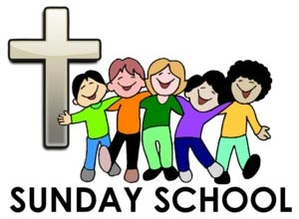

Due to cold, windy and snowy weather, the hayride and bonfire had to be changed to indoor family game day with hotdogs, s’mores, hot chocolate and hot cider. We had 18 students and 11 adults enjoy the day.

Did you see the Thankful Tree in the South entrance? The students added the leaves that tell many of the things that they are thankful for. God has given us so much, and this was a project where we asked the students to discuss why they are grateful.

Small change to class plans… the students will stay in the sanctuary following church service each week. Pastor will teach the lesson in the sanctuary, and then we will move to the fellowship hall for snacks and crafts or activities or music or puppet skit. It’s easier for Pastor to talk with the kids in the quietness of the sanctuary. Thanks for being adaptable.

We will be decorating cookies for the Christmas Gift packages during class on Dec 6th. I could use some help from Sunday School families to get the packages delivered. Let me know if you can help.


We are planning a Sunday School Christmas program that will be a hybrid-type service on Sunday, December 13th at 4:30 p.m. Each family will have a pre-recorded ‘part’ in the program, the kids will play bells, and we will be singing several Christmas hymns as a congregation during the service.

After the program, everyone is invited to the fellowship hall for our annual Pizza Party! We will practice safe social distancing, so don’t be afraid to join us for a slice. If you don’t feel comfortable eating with us, you can grab a slice to go. Thank you to Chuck Wright for a Thrivent Grant to offset the cost of candy bars (for the kids) and pizza for the party.

There will be no class on Sunday, Dec 27th so that families may continue to celebrate Christmas with their families.

Remember, Jesus is the Reason for the Season!

Susan Schember, Sunday School Superintendent
586 246-4567


We used the profits from the soups and sweets sale to purchase Christmas gifts for a family from each of the following schools: Cass City, Bad Axe, and Lakers. Thank you to Michelle Reibling, Ruth Fluegge, and Melissa Deming for delivering them. Students are asked to help wrap gifts on Sunday, December 6th at 10:30am.


With all the Covid restrictions right now, we can’t plan any big outings. I am hopeful to get together for some fun later this winter. We are looking at the possibility of renting the Caseville Roller Rink for a Youth Group/Sunday School field trip in January. In the meantime, I hope to see you in church. If your family is not comfortable coming in-person, I encourage you to join us online.

UPDATE FOR SOUPS AND SWEETS SALE

The Youth Group Soup and Sweets Sale was a huge success! There are a lot of people to thank, so bear with me for a minute. Without the help of everyone, we couldn’t have done it. First, thanks to everyone who placed orders or got orders from family/friends, coworkers. Second, thanks to Sandy Salcido, Brandy Gunsell, Katie & Lola Stein, Marge Weisenbach, Grace & Clare Suggitt, and Melissa Deming for all the cooking and prep work. Thanks to the people who donated Thrivent Grants for the groceries and paper products to offset costs. And thank you to the youth group kids and parents who helped package, clean up and deliver soup and sweets.


We made over 300 quarts of soup and over 200 turnovers for this sale. At the end of the sale, we donated leftovers to Birch View and Fiddler’s Green. The profits (about $2,300) from this sale were used to purchase Christmas gifts for our adopt-a-family program, donated $100 to Imagination Library and $100 to The Blessing Box Project.


HOLIDAY GIFT PACKAGE DELIVERIES

The Sunday School and Youth Group families will be packaging and delivering gift bags to many of the elderly members of our congregation during December. Thanks to a Thrivent Grant, we will be making Christmas cookies and purchasing some little gifts to put in the packages. These gift bags are just a small token of appreciation to those members of our congregation who made St. Paul the wonderful church that our children can call home. This year has been challenging for everyone, and we wanted to make sure to thank all of you for everything you do and have done for our church through the years!

I will need help from Sunday School and Youth Group families to deliver these packages on Dec 6th after Sunday School. Please let me know if you can help.

Susan Schember
586 246-4567 bssandsks@yahoo.com


Fern Dubs  2423 Smith Road  Bay Port, MI 48720  (989) 453-2959 | Don Fibranz  Satchell’s Christian  Foster Care Home  2662 E. Caro Road  Caro, MI 48723
Mabel Kain  Country Gardens  203 N. Caseville Rd.  Room 401  Pigeon, MI 48755  (989) 453-3374 | Beverly Liedke  160 Country Bay Drive  Room 308  Pigeon, MI 48755  (989) 453-3637
Barbara Main  7717 Berne Road  Bay Port, MI 48720  (989) 553-3620 | Bonnie Nowaczyk  7305 Main Street  Owendale, MI 48754  (989) 553-4286 or  (989) 678-4286
Dorothy Prich  Courtney Manor  Room 214  167 E. Hopson  Bad Axe, MI 48413  (989) 269-6534 | 


Your Christmas donation envelope has been included with this issue of the “Epistles”. You may place it in the collection plate at any service or mail to the church.


Any of these items are welcome for the Food Pantry at any time.

Item List
for
Food Pantry

Crackers
Cereal
Pancake Mix & Syrup
Canned Vegetables
Canned Fruit
Fruit Juices
Peanut Butter
Jelly
Ketchup
Mustard
Toilet Paper
Paper Towels
Laundry Detergent
Dish Detergent
Shampoo
Conditioner
Tooth Paste
Canned Spaghetti-O’s
Canned Ravioli
Tuna Fish
Boxed Mac & Cheese
Spaghetti
Spaghetti Sauce
Canned Beans of all kinds
Ramen Noodles

St. Paul’s Adopted Seminary Student

As we seek to support the proclamation of the Gospel, St. Paul has a seminary student to support as he receives theological training in order to be placed into the Office of the Holy Ministry. Seminarian Christian Mundorf is in his second year of study at Concordia Theological Seminary, Fort Wayne, Indiana. He hails from Saline, Michigan and is a graduate of Valparaiso University. Please remember seminarian Mundorf as we pray for him and also support him with financial assistance as he seeks to serve in our Lord’s church. You may designate an offering to go toward Sem. Mundorf as indicated on your offering envelope.
Christian Mundorf
6600 North Clinton Street Box 358
Fort Wayne, IN 46825

++++++++++++++++++++++++++++++

Want to listen to good theology concerning current topics, the Bible, and Christ crucified for you? Check out Issues, Etc. on your computer or smartphone.





A message from our seminarian:

Thank you so much for your continued support of my seminary education. In these unprecedented times, it means so much to me to know that you are praying for me and helping me through my studies. I am looking forward to my upcoming vicarage placement assignment in the spring, and I ask for your prayers for that.

Additionally, I will be getting married in January to my wonderful fiancée, Abby Dester, who is working towards a Ph.D. in Psychology at Michigan State.

As always, thank you for your support.

God’s Blessings,
Christian Mundorf


LutheranPublicRadio.org
Dec. 4 – Mitchell Schaper
5 – Wayne Dubs
6 – Cory Ornowski
8 – Ron Dubs, Jr.
12 – Angie Marie
12 – Harold Haag
13 – Joe Salcido, Sr.
14 – KatyAnna Kruse
14 – Suzanne Fritz
15 – Zachary Schember
15 – Grace Suggitt
17 – Kristin Rifenbark
20 – Krissia Krohn
21 – Tammy Timmons
22 – Cody McGee
22 – Ryan Tabar
23 – Richard Fluegge
24 – Matt Reibling
25 – Morris Dubs
26 – Anyssa Mandich
26 – Raymond Errer
28 – Dennis Schweitzer
28 – Kimberly Krohn
29 – Norbert Reehl
29 – Brady Renn
30 – Kyle Truemner
30 – Lee Truemner
30 – Randy Dubs
31 – David Gilbert


Dec. 8 – Dennis & Linda Schweitzer
Dan & Dedra Sherman
10 – Bryan & Jamie Parrish
28 – Michael & Anyssa Mandich
In His Service

December Elders
Dec. 2 – Advent Service @ Good Shepherd
Dec. 6 – Warren Stoeckle & Ron Tabar
Dec. 9 – Manuel Thies
Dec. 13 – Marc Reinhardt & Josh Sprague
4:30 p.m. – Children’s Christmas Program
Dec. 16 – Advent Service @ Good Shepherd
Dec. 20 – Joe Salcido & Ken Haley
Dec. 24 – 7:00 p.m. Christmas Eve Service
Warren Stoeckle & Ron Tabar
Dec. 25 – 8:30 a.m. Christmas Day Service
Joe Salcido & Ken Haley
Dec. 27 – Marc Reinhardt & Josh Sprague

Tithe Counters
Dec. 13 – Kim Krohn & Patti Reinhardt
Dec. 27 – Ruth Fluegge, Liz Reehl, Kari Ricker

December Altar Guild
Ruth Fluegge
Paula Holland

December Altar Flowers
Ruth Fluegge
Kris Gilbert



Orphan Grain Train of Sebewaing

A container is located in the narthex to collect goods. Please refer to the list of appropriate items.
Sun | Mon |  | Tue |  | Wed |  | Thu |  |  | Fri |  | Sat
 |  |  | 1  6:15PM  Elders  7:00PM  Council |  | 2  7:00 PM  Advent Vespers  @  Good Shepherd |  | 3 |  |  | 4 |  | 5
6  8:30 AM  Service  9:30 AM  Sunday School  Ladies Aid Mtg.  1:30 PM  Catechism | 7  6:30 PM  Bible  Study |  | 8  Pastor  @  Winkel |  | 9  7:00 PM  Advent Vespers @  St. Paul |  | 10 |  |  | 11 |  | 12
13  8:30 AM  Service  9:30 AM  SS / Coffee Hour  4:30 PM  Children’s  Service  Pizza Party  1:30PM  Catechism | 14  6:30 PM  Bible  Study |  | 15 |  | 16  7:00 PM  Advent Service  @  Good Shepherd |  | 17 |  |  | 18 |  | 19
20  8:30 AM  Service  No Catechism | 21 |  | 22 |  | 23 |  | 24  7:00 PM  Christmas  Eve  Service |  |  | 25  8:30 AM  Christmas  Day  Service |  | 26
27  8:30 AM  Service  No SS  No Catechism | 28  Pastor Away | 29  Pastor Away |  | 30  Pastor Away |  | 31  Pastor Away |  |  | JAN. 1  2020  Pastor Away |  | JAN. 2  Pastor Away
December



St. Paul's "Epistles"
St. Paul Evangelical
Lutheran Church
7292 Kilmanagh Rd.
Pigeon, MI 48755

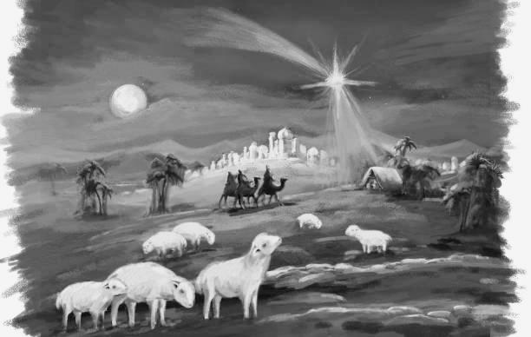
O Come, O Come, Emmanuel

