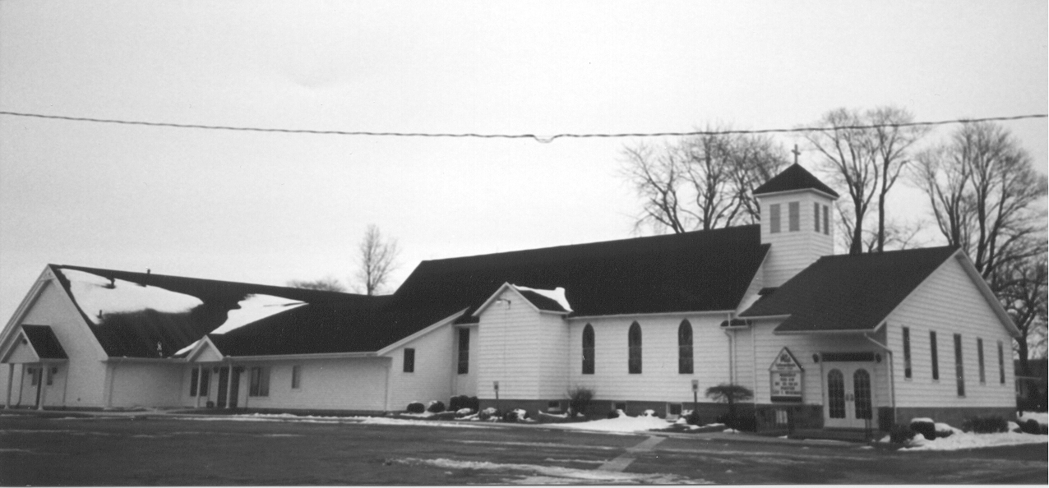St. Paul's
" E p i s t l e s"
December 2022 Volume 39 No. 2

The season of Advent is not a bah humbug to Christmas, it prepares us for it. Advent forces us to long for our Lord’s return even as we wait to celebrate the fact that He has already come in the flesh. Within Advent, we are called to consider Jesus’ return on the final day and in the midst of our lives lived out in faith we are given the answer to John the Baptist’s question from prison when he inquires of Jesus, “Are you the one who is to come, or shall we look for another?” (John 11:3). The answer is yes. Jesus is the one to come and will come again.

How can we prepare for His coming on the final day? We are prepared when we live in repentance and faith clinging to His promises which are given out through His Word. So it is that there are Midweek Advent services to give you more hearing of that Word, prayer with your church family, singing of the things of Christ, and Advent devotional books to aid you in the home. This is how Jesus tells us to watch for Him and to stay awake, by lifting our heads to where His voice is heard. His coming on the final day will be a day of great joy for us who have been bought back from our sins and find salvation in Him alone.

This brings us to another aspect of Advent. That God, the Son of God, has to come in our flesh and die for us in order for us to be released from the bondage of our sin. This is no small thing to reflect upon. That my sins require divine blood to be spilled. This is a humbling reality. It should make us pause and consider what it is that we rejoice at on Christmas. The Son of God comes in the flesh to die our death. It’s not simply a cute baby in the manger, but a sacrifice, a perfect lamb born to redeem wayward sheep. And that’s what He does. Comes to be our substitute in whom we have life - who brings us out of the darkness of death and into His marvelous light of life. This is what Christmas is about and Advent helps prepare us for this most beautiful news. That we have a God who dwells with man to be our Savior by being born, dying, rising from that death, and will come back for us. Could you wrap a better present than that? No, you could not.

Among the bustle of this time of year, slow down and ponder these sacred and holy things. Prepare joyously for our Lord’s return even as you prepare to burst forth on Christmas morning about His birth in the flesh. These are eternal things which remain true even after the radio stops playing Bing Crosby and Johnny Mathis. They will fortify you during your work party, your third family gathering, and one more trip to the store because you will be heartened by that which never fizzles out: Christ comes even for you. Not only at His birth or on the final day, however. But now. This Advent, if you’re considering the best way to keep Christ in Christmas as it approaches, then come to church. You will be blessed.

Merry Christmas,
Pastor Suggitt
It’s LUTHERAN WITNESS time!

It's time to re-subscribe or subscribe to THE LUTHERAN WITNESS at a discounted rate. The Lutheran Witness is the official periodical of The Lutheran Church—Missouri Synod and is published 11 times a year. It provides Missouri Synod laypeople with stories and information that complement congregational life, foster personal growth in faith, and help interpret the contemporary world from a Lutheran Christian perspective. Subscriptions ordered through your church will include the Michigan In Touch supplement. The new subscription year doesn't begin until March 2023, but orders need to be to the District office by December 15, 2022 to take advantage of a discounted District rate of $12.00/year. (Individual subscriptions ordered directly from CPH are $19.99/year.) Payment for subscriptions should be made directly to your church office by December 9th.

Life Quote

The birth of Christ is the ultimate solution to the loneliness that began in the Garden of Eden. Jesus came because God cares about lonely people, and so should we. Find opportunities to give lonely people gifts—not merely physical items, but the gift of your
time, presence, and encouragement. May the glorious Gospel that is preached to you in the birth of Jesus be the gospel that you preach to yourself and your family this month.

A Life Quote from Lutherans For Life • lutheransforlife.org

ADVENT MIDWEEK SERVICES

Let the word of Christ dwell in you richly…
Colossians 3:16

As the world scrambles to find riches at the mall and online shopping, come find rest in the Word of Christ and the richness of His eternal inheritance. Join your brothers and sisters in Christ on Wednesday evenings during this season of Advent to hear God’s Word, sing hymns, pray, and thus dwell richly and securely in the King who comes.

December 7 @ St. Paul, Linkville
6:00 p.m. Supper
7:00 p.m. Vespers

December 14 @ Good Shepherd, Caseville
7:00 p.m. Vespers

December 21 @ St. Paul, Linkville
6:00 p.m. Supper
7:00 p.m. Vespers


The regular meeting of St. Paul Ladies Aid was called to order by President Ruth Fluegge on Sunday, November 6, 2022 following our worship service.

A devotion from the day’s Portals of Prayer was read by the secretary – ‘All with faith in Christ will live forever—you will live forever—in Christ by faith, trusting in His blood shed on the cross for salvation’.

Members then recited the Mission Statement for our organization. Eleven members answered roll call.

Old Business:
- Sandy needed an answer as to whether or not we were doing the cheeseballs this year. A motion was made, supported and carried to make them on November 19, 2022. Sandy will order the supplies and post a job sheet for volunteers. The cost per cheeseball will remain the same as last year - $7.00 as we did not have to purchase containers this year.
- Much discussion was held on the bazaar – what worked, what didn’t.
- Take & Bake casseroles
- Small lasagnas sold better than the large ones.
- Pot pies sold well.
- Mac & Cheese didn’t sell well. We won’t make them next year.
- Potted plants were price too high. No plants next year.
- Pie Station worked well. We had requests for raspberry and more lemon pies. We’ll make more next year.
- Gift Baskets – Joyce stated that she would not make them next year. We will not advertise gift baskets on the flier. If anybody wants to make them, that’s fine.
- Discussion was held concerning the storing from week to week of the altar flowers while the horseradish is in the basement refrigerator. The flowers will just be placed on the counter while the horseradish is there.
- Several people commented that there was too much chicken salad in the sandwiches. Will back off on the chicken next year.
- Ruth Kumaus stated that on the day of the bazaar we took in approximately $16,300.

New Business:
- Discussion was held concerning the possibility of having to replace appliances in the kitchen. Ruth Kumaus made a motion to move $4,000 to the savings for this purpose; supported by Wendy Tabar; carried.
- We discussed further support of Rev. Josh Errer’s continuing education in the ministry. A motion was made by Margaret Timmons to donate $2,000 to him for this purpose; supported by Sandy Salcido; carried.
- A motion was made by Wendy Tabar & supported by Wanda Dubs to adjourn our meeting; carried.

The meeting closed with singing the doxology and reciting the Lord’s Prayer.

Respectfully submitted,

Sandy Salcido, Secretary


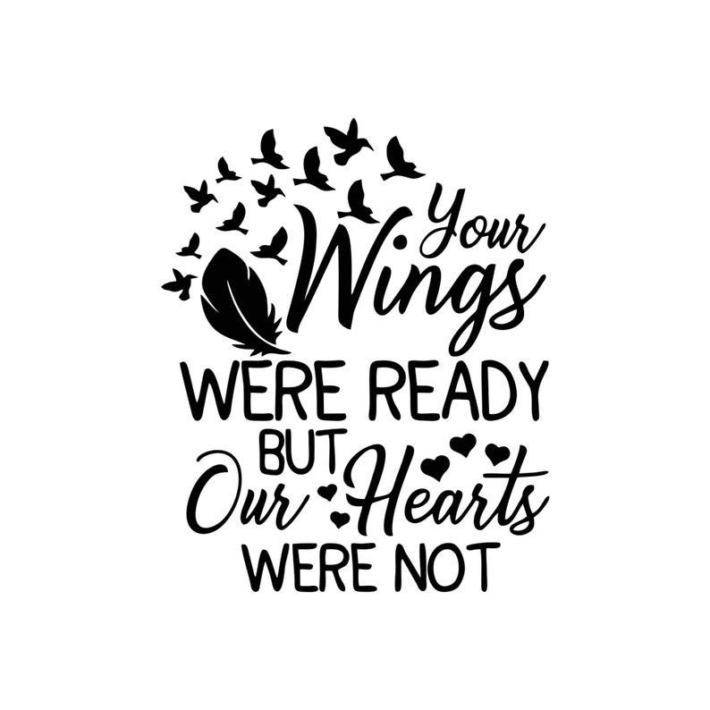

Mabel Anna Kain was given life by her creator and was born on October 8, 1918, the child of John F. and Clara E. (Koch) Buehler. She was born anew in the waters of Holy Baptism and sustained by our Savior’s Body and Blood beginning at Immanuel Lutheran Church, Sebewaing. On February 3, 1940 she received the gift of a beloved companion in her spouse, Russel. God blessed Mabel’s life with loving family and friends and guided her work at St. Paul as she served on the Ladies Aid for sixty-six years as well as the St. Paul Funeral Committee. Finally, on November 19, 2022, God blessed Mabel with a holy death and took her home to rest in the arms of Jesus to await the resurrection of the dead.

The Lord gives and the Lord takes away; blessed be the name of the Lord. We give thanks to God our Father through Jesus Christ, our Lord, for our sister Mabel.

PRIVATE CONFESSION AND ABSOLUTION

From the Small Catechism: Confession

What is confession?
Confession has two parts. First, that we confess our sins, and second, that we receive absolution, that is, forgiveness, from the pastor as from God Himself, not doubting, but firmly believing that by it our sins are forgiven before God in heaven.

Private, or individual, confession and absolution is available by appointment with Pastor Suggitt. You may call him at 989.551.3976 to set up a time.

St. Paul's "Epistles" is published monthly by St. Paul Evangelical Lutheran Church, 7292 Kilmanagh Road, Pigeon, MI, 48755.

Pastor: Rev. Christopher Suggitt

Church & Office Phone: (989) 453-2271
Pastor Suggitt’s Cell Phone: (989) 551-3976

Church Email: lvlspaul40@gmail.com
Secretary’s Email: salcido.sandy8@gmail.com

Sunday Worship: 8:30 a.m.
Sunday School: 9:30 a.m.

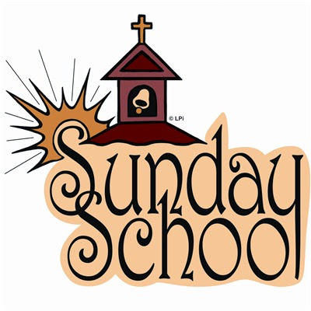

The Cookie Walk at the bazaar was a huge success! Thanks to everyone who baked and helped. We used some of the profits for Family Bowling at Bad Axe on November 13th. We had 52 people attend – and about half of them bowled. We also used part of the money to purchase 4 turkeys for Thanksgiving Adopt-a-Family.

The kids played bells on November 13th and sang on November 20th during our church service. We will be singing with the adult choir on December 18th and playing bells during Christmas Eve service.


Our Christmas program will be Sunday, December 18th at 4:00 p.m. Everyone is invited to come watch the kids put on a mini-play and then join us for Pizza, snacks and beverages at 5:00 p.m.

***Parents: please work with your kids to memorize their lines and practice the acting parts. If they spend 5-10 minutes each day, they will be ready!

The Sunday School provided Thanksgiving Feast boxes to one family from each of the following schools: Bad Axe, USA, Lakers, and North Huron. Sunday school funds purchased 4 turkeys and 4 gift baskets; we also donated 4 home-baked pies, 8 take-n-bake macaroni and cheese, and 4 pkgs. of specialty cookies from the bazaar. Sunday school families donated all the rest of the groceries to complete the meals (plus some!) Thanks to Michelle Reibling, Paula Holland, and Melissa & Lance Deming for delivering the packages.

We did not have class on November 27th, but we practiced some music immediately after church, and did What’s in the Box?, and had coffee hour. We will not have class on December 25th and January 1st. I don’t anticipate having coffee hour on those days.
*We’re hosting advent supper on Dec 7th. See note about that!

Do you know any young families who are looking for a new church to attend? Invite them to come check us out this Advent and Christmas season! New children are always invited to come to Sunday School and Youth Group.

May the Lord bless you and your family as we prepare for the Coming of Jesus Christ on Christmas Day!

Susan Schember, SS Superintendent
586 246-4567

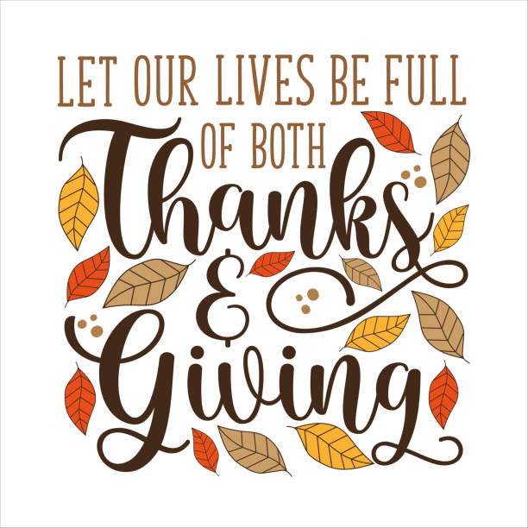
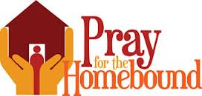


Fern Dubs  2423 Smith Road  Bay Port, MI 48720  (989) 453-2959 | Don Fibranz  Satchell’s Christian  Foster Care Home  2662 E. Caro Road  Caro, MI 48723
Peggy Kelly  6282 Pine Street  Cass City, MI 48726  (989) 872-5086 | Beverly Liedke  160 Country Bay Drive  Room 308  Pigeon, MI 48755  (989) 453-3637
Bonnie Nowaczyk  7305 Main Street  Owendale, MI 48754  (989) 553-4286 or  (989) 678-4286 | 
Keep them in your prayers, maybe give them a call and/or visit them.


Your Christmas donation envelope has been included with this issue of the “Epistles”. You may place it in the collection plate at any service or mail to the church. Extra envelopes have been placed on the table by the bulletin board.

Any of these items are welcome for the Food Pantry at any time.

Item List
for
Food Pantry

Crackers
Cereal
Pancake Mix & Syrup
Canned Vegetables
Canned Fruit
Fruit Juices
Peanut Butter
Jelly
Ketchup
Mustard
Toilet Paper
Paper Towels
Laundry Detergent
Dish Detergent
Shampoo
Conditioner
Toothpaste
Canned Spaghetti-O’s
Canned Ravioli
Tuna Fish
Boxed Mac & Cheese
Spaghetti
Spaghetti Sauce
Canned Beans of all kinds
Ramen Noodles




We had a great turnout for Axe Throwing on November 12th. There were 22 of us throwing! Super fun and no missing fingers or toes! Pastor Suggitt had high score with 31. Josh Sprague was a close 2nd with 29. And then Michelle Reibling and Grady Bolzman tied for 3rd with 25. Some of us struggled a bit hitting the target, but EVERYONE scored at least once! Next time we might try fowling.


Our next project is Christmas Adopt-a-Family. We will be boxing up gifts on December 18th after Sunday School. This year we will box the gifts and provide wrapping paper and gift bags for the families (so the parents know what we bought).
*We’re hosting advent supper on Dec 7th. See note about that!

The Thumb area LCMS churches are planning a youth gathering event in Cass City in March. This will be an all-day event geared toward youth in 8th -12th grades. 6th and 7th grade students might also be included. St. Paul is responsible for acquiring 2 Thrivent Grants to help with cost of two meals and snacks for the event. Please let me know if you’d like to donate a grant (it could even be a leftover from 2022). If any adults are interested in volunteering at the event, they will be happy to have you. Tentative date is March 11th, with back-up date March 4th. I will keep you posted as dates are confirmed.

Susan Schember, Youth Group Leader
586 246-4567
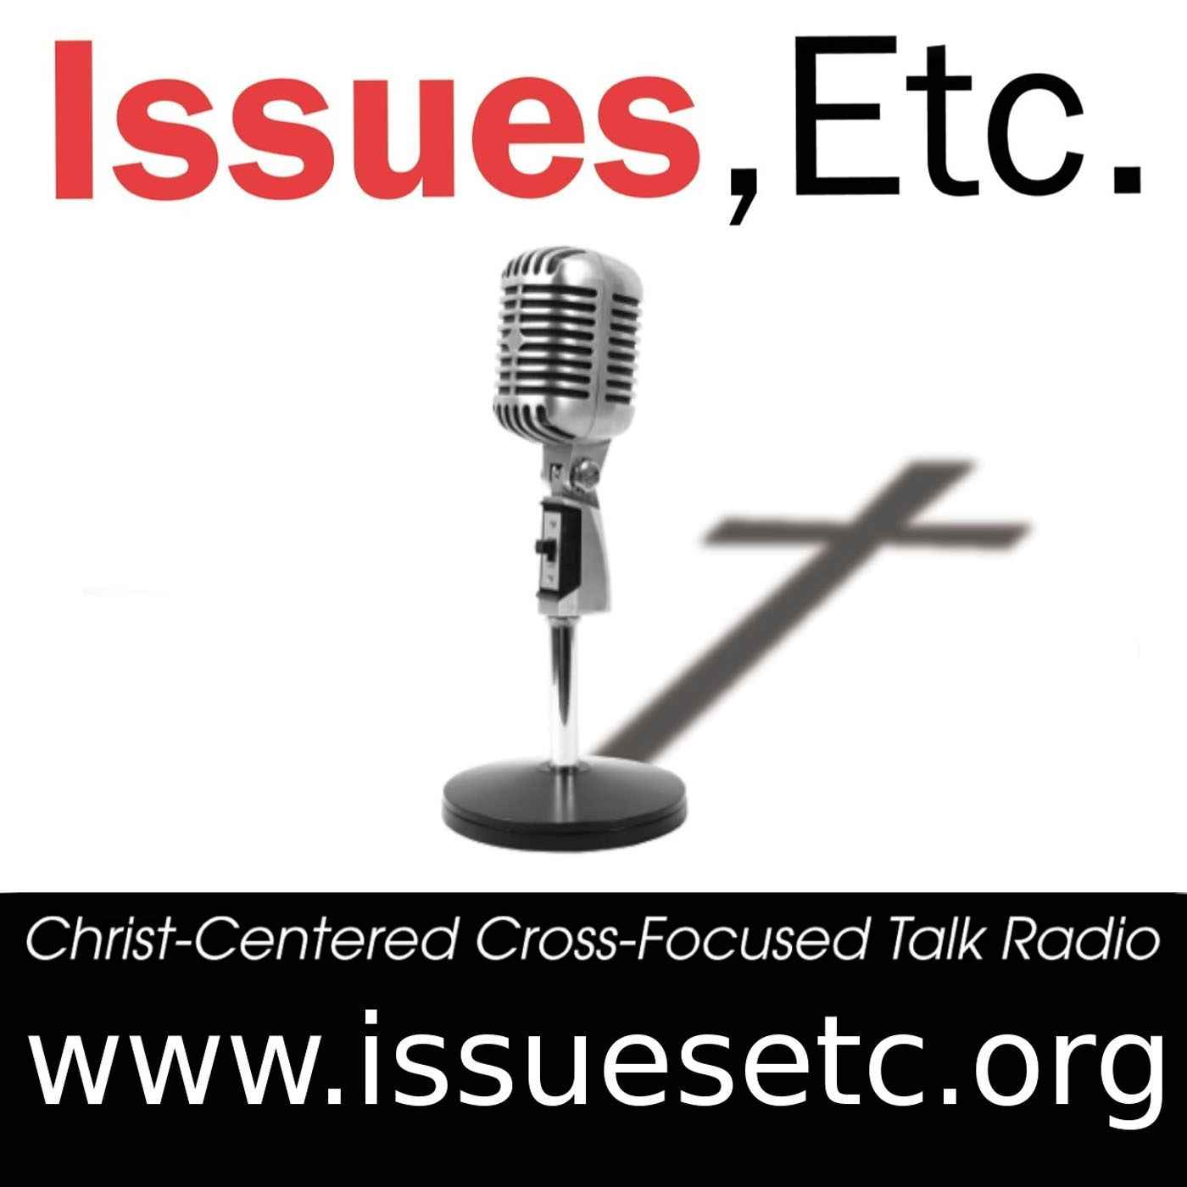

Want to listen to good theology concerning current topics, the Bible, and Christ crucified for you? Check out Issues, Etc. on your computer or smartphone.

**************************************************



Has your family ever discussed being greeters at church? The job consists of arriving early at church two or three times a YEAR, opening the door for those who need assistance, and greeting people with a smile. That's all there is to it!

If your family is interested, please contact Faye. She will be more than glad to add you to the list and even give you the Sundays that work for your family!



Sun | Mon |  | Tue |  | Wed |  | Thu |  |  | Fri |  | Sat
 |  |  |  |  | 1  6:00 PM  Supper  7:00 PM  Advent Vespers  @  St. Paul |  | 2 |  |  | 3 |  | 4
5  8:30 AM  Service  9:30 AM  Sunday School  1:30 PM  Catechism | 6  6:00 PM  Choir |  | 7  6:15PM  Elders  7:00PM  Council |  | 8  7:00 PM  Advent Vespers @  Good Shepherd |  | 9 |  |  | 10 |  | 11
12  8:30 AM  Service  9:30 AM  SS / Coffee Hour  4:00 PM  Children’s  Program  Pizza Party  No  Catechism | 13  6:00 PM  Choir |  | 14 |  | 15  6:00 PM  Supper  7:00 PM  Advent Vespers  @  St. Paul |  | 16 |  |  | 17 |  | 18
19  8:30 AM  Service  No Catechism | 20  6:00 PM  Choir |  | 21 |  | 22 |  | 23  7:00 PM  Christmas  Eve  Service |  |  | 24  8:30 AM  Christmas  Day  Service |  | 25
26  8:30 AM  Service  No SS  No Catechism | 27 | 28  2022 |  | 29 |  | 30 |  |  | 31  5:00 PM  New Year’s  Eve Service
December



St. Paul's "Epistles"
St. Paul Evangelical
Lutheran Church
7292 Kilmanagh Rd.
Pigeon, MI 48755

