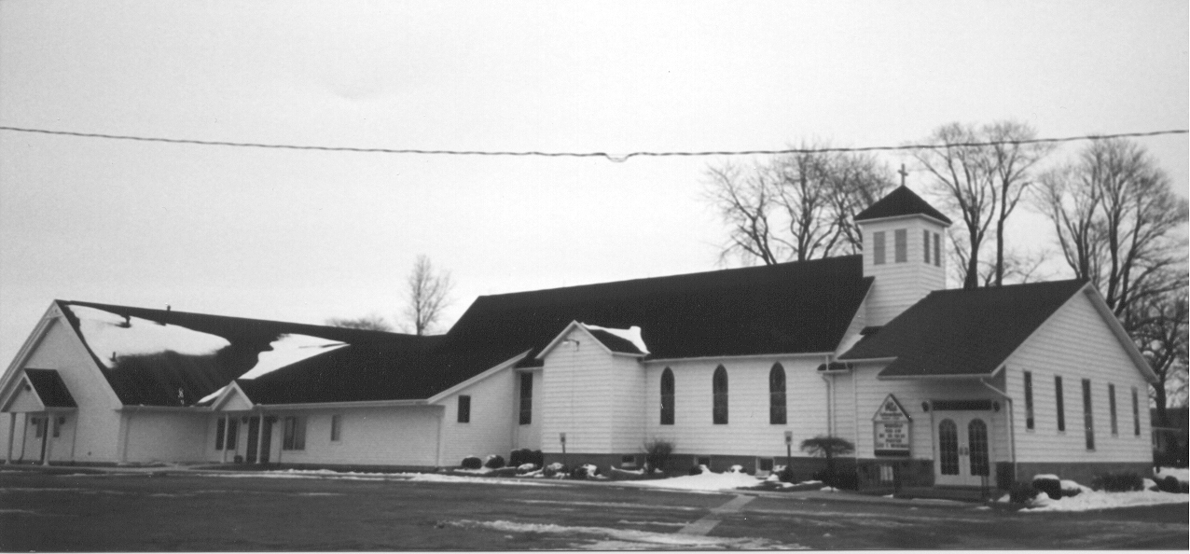St. Paul's
" E p i s t l e s"
November 2022 Volume 39 No.1

On the schedule this month for the youth is axe throwing. You read that right. Axe throwing. For the youth. Sounds like a dangerous endeavor, doesn’t it? Well take heart, I’ve done this before and the company does a good of job taking safety precautions and leading everyone through proper technique and axe handling so that everyone leaves with all their digits. Hopefully.

The targets are clearly defined. Usually a big red bullseye in the center with a few concentric circles moving out from that point. Each target is located within a lane with walls or fencing to keep a stray axe from another lane finding its way to do damage in yours. The goal, of course, is to hit the bullseye. Yet you’re not trying to simply hit the bullseye, but rather are trying to make the axe stick and remain in the bullseye. This can take patience and endurance, but is worth the effort once you hear that thump of the axe blade burying itself into the wood.

Is this not like your life in Christ? Can we and our families learn something from axe throwing? I say yes. In the world you will have tribulation, says Jesus, and indeed we see it. All kinds of danger seeking to pull us away from our Lord. Worry and fear about money because of inflation; wars and rumors of wars to keep us on edge; blatant attacks on God’s natural created order for men and women and the family; indifference to any sort of moral compass or thought of God because everyone has their own “truth.” Axes are flying and it seems as if no one will get out unscathed.

Because of this you need to be kept safe. So the Holy Sprit calls you into the safety of Christ’s church (see the Third Article of the Creed in the Small Catechism) to keep you in the one true faith. Our Lord Jesus puts you in a lane, so to speak, to keep you safe from wayward axes and puts the target in front of you - for you to see what’s important. And that’s Him and His Word. In the world you will have tribulation, He says, but take heart, I have overcome the world (John 16:33).

Knowing that through His death and resurrection, Jesus has overcome the dangerous, wayward axes of the devil, the world, and our sinful flesh, we focus our eyes on Him. We teach our families to do the same. Parents, do you want your children wandering outside the lane with nothing to protect them? Do you want them throwing their axe so that it lands anywhere? They are going to throw it - show them where. Show them the target and how to aim. Model it for them. Christians, do this for each other. Read the Bible and pray for a purpose - to make it stick. St. Paul says it a little differently than the axe throwing analogy here but the premise is still the same, In all circumstances take up the shield of faith, with which you can extinguish all the flaming darts of the evil one; and take the helmet of salvation, and the sword of the Spirit, which is the word of God, praying at all times in the Spirit, with all prayer and supplication (Ephesians 6:16-18).

Jesus desires to keep you safe so He let every flying axe hit Him that you might live. The Last Sunday of the Church Year is upon us (Nov. 20) and we are called to examine what we have set our sights on. God grant it that we keep our focus on that target of the cross and by His grace hone our technique through hearing His Word and promises and living lives centered on the bullseye of His truth.

In Christ,

Pastor Suggitt



Youth group kids were a big help with horseradish and bazaar setup. Hoping to have even more help from them for bazaar!

We are heading to Main Events in Cass City on November 12th at 4:00 p.m. for axe throwing! If you haven’t signed up yet, please do so right away. Youth group funds will pay for this event. Feel free to bring money for drinks or snacks.

The youth group is adopting four families for Christmas. We will provide gifts for families from USA, Lakers, Bad Axe, and North Huron schools who might not otherwise be able to afford them. We will wrap gifts on Sunday, December 18th after Sunday School.

The Thumb Area Lutheran Churches are planning a Youth Group Event in March at Good Shepherd. I have volunteered to acquire 2 Thrivent Grants to help with meals and snacks. If anyone in the congregation would like to apply for these grants, please let me know. More info to come once plans are confirmed. This event will be aimed at 7th-12th graders.

DON’T FORGET DAYLIGHT SAVINGS TIME ENDS THE WEEKEND OF NOVEMBER 6TH. NO EXCUSE FOR MISSING CHURCH – YOU’LL GET AN EXTRA HOUR OR SLEEP!

Looking Ahead
St. Paul is hosting Advent suppers on December 7th and 21st. Sunday School and Youth Group will be December 7th 6:00 p.m., and Choir will be December 21st 6:00 p.m. Advent Mid-Week Service will follow at 7:00 p.m. Mark your calendars now.



Classes are going great. The kids are enjoying “What’s In The Box?” each week with Pastor Suggitt. We played bells in early October and are singing with the adult choir for Reformation Sunday. The kids, parents and teachers were a great help with horseradish day and bazaar setup. Then on October 23rd St. Paul Sunday School enjoyed a fun time at Kohl Farms. Pumpkin Sales proceeds paid for 25 students and parents to attend the corn maze.

The bazaar and cookie walk are the next big event. Hoping for lots of helpers to make it a big success. Thanks ahead of time for all our cookie bakers and volunteers. On November 13th we are taking another field trip to Bad Axe Lanes for bowling. Cookie Walk money will help pay for the fun. WE ARE PLAYING BELLS THAT DAY!

If you haven’t signed up to provide a snack for coffee hour yet, please check out the list. Please bring 5 dozen treats/snacks to cover kids, teachers, and other coffee hour people. Drinks are provided.

Sunday School has adopted families from USA, Lakers, Bad Axe, and North Huron schools to provide Thanksgiving Dinners. We will purchase turkeys for each family with Cookie Walk proceeds. Sunday School families are asked to donate the rest of the groceries to complete a Thanksgiving Feast for 4 families – potatoes, green beans and mushroom soup, stuffing, rolls, pies, sweet potatoes, etc. Please bring in all donations to church by Sunday, Nov 20th, so the packages can be delivered that Monday.

I’m also trying to plan a Children’s Christmas Program. Right now I’m looking at Sunday, December 18th at 4:00 p.m. Once the bazaar is over, I can finalize plans and we will start practicing.

The regular meeting of St. Paul Ladies Aid was called to order by President Ruth Fluegge on Sunday, October 2, 2022, following our worship service.

A devotion from Portals of Prayer was read by the Ladies Aid secretary – ‘Ask, and it will be given to you.’ from Matthew 7:7. God wants us to turn to Him with whatever trials we may have, first rather than as an afterthought.

The Ladies Aid Mission Statement was read. Nine members answered roll call.

Our treasurer, Ruth Kumaus, reported that we have about $16,000 in the checking account.

Old Business
Discussion was held concerning the upcoming bazaar.
- Several slots for workers at the bazaar are still unfilled. We’ll work on getting those filled.
- The lasagnas have been produced and frozen. We decided that the Mac N Cheese recipe that Peggy got was quite expensive to make so we chose another recipe. The Macaroni & cheese casseroles will be produced on Friday, October 7th at 10:00 a.m. Volunteers are needed to help cook and package. Chicken pot pies will be made the week of the bazaar.
- Jan Stoeckle called Sandy concerning the advertising for the bazaar. She wanted to know if we wanted her to do it again this year. We had somehow missed contacting her. Sandy gave her the OK to do the same advertising she had done previously.
- Concern was voiced about freezer space in preparation for the bazaar. Lots of pies have been frozen and more will be made soon. With the casseroles we’ve made we may need home freezer space until the pies are baked for the bazaar. Several people volunteered freezer space.

New Business:
Discussion was held on what donations we would make this year. The following gifts will be given:
- Seminary student - $500 (2 semi-annual payments)
- Josh Errer – $2,000 donation toward his continued education
- Seminary student (Christmas) – $500
- Lutheran Fraternity – $500
- Pigeon Food Pantry – $500
- Thumb Blessing Boxes – $500
- Huron County Safe Place – $500
- Alaskan Ministry – $500
- Orphan Grain Train – $500
- Clothe-A-Child – $250
- Imagination Library – $500
- Laker Schools – $500
- Owen-Gage Schools – $500
- Cass City Schools – $500
- USA Schools – $500
- Bad Axe Schools – $500

Each of the above was voted upon, supported and carried.

Ruth Kumaus brought up an acquaintance who does fostering. She will find out more and let us know if it’s something we can help with.

Joyce Metzger made a motion to adjourn the meeting; supported by Wendy Tabar; carried.

The meeting closed with singing the doxology and reciting the Lord’s Prayer.

Respectfully submitted,

Sandy Salcido, Secretary

St. Paul's "Epistles" is published monthly by St. Paul Evangelical Lutheran Church, 7292 Kilmanagh Road, Pigeon, MI, 48755.

Pastor: Rev. Christopher Suggitt
Church & Office Phone: (989) 453-2271
Pastor Suggitt’s Cell Phone: (989) 551-3976

Church Email: lvlspaul40@gmail.com
Secretary’s Email: salcido.sandy8@gmail.com

Sunday Worship: 8:30 a.m.
Sunday School: 9:30 a.m.
Youth Catechism: 1:30 p.m.



A BIG THANK YOU GOES OUT TO THE FOLLOWING SPONSORS FOR THE BAZAAR:

- Pioneer Michigan Sugar who donated white, brown, and powdered sugar for our baking and canning needs.
- Coca Cola Company who donated all the water, soda, and iced tea for the luncheon.
- Pigeon Co-op who donated the navy beans for our soup
- Thrivent Financial who provided grants for many areas, including: luncheon, bake sale, cookie walk, canning, take n bakes, and gift baskets.
- Sherwood on the Hill who donated all the ice for the bazaar.

DID YOU KNOW?.....

Thrivent Financial Members are eligible for 2 – $250 grants per year. Grants for this year can be applied to events in 2023! Grants are available to be used up to 120 days from the date of application (so if you applied for a grant on December 30th, you could use it for any event thru April 29th.)

Thrivent also donates additional money toward the non-profit organization of your choosing several times per year through Choice Dollars. You can choose St. Paul or another organization of your choosing as your Choice Dollars beneficiary. If you are unsure about your Action Grants or Choice Dollars, please reach out to Faye Errer or Susan Schember to get help. Don’t let your FREE MONEY GO TO WASTE – LIVE GENEROUSLY!
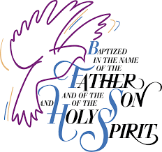

On Sunday, October 23, 2022 we were blessed to welcome into the family of faith at St. Paul by the washing and renewal of Holy Baptism, Jett Charles Tucker, infant son of Kaitlyn Reinhardt and Chase Tucker. Jett is the grandson of Jason and Patti Reinhardt. Serving as sponsors for Jett are Adam Reinhardt, Karly Cunningham, Shelby Flores, and Brandon Tucker.

Please keep Jett and his family in your prayers as they live their lives together in Jesus.



LIFE QUOTES

Abortion isn’t somebody else’s issue. It’s your business, it’s my business, and it’s our business. It’s our issue as Christians, it’s our issue as citizens, and it’s our issue as human beings. Abortion and the sanctity of every human life matter very much for elections—more so than anything else. And it matters for much more than elections. It’s a whole life issue!”

A Life Quote from Lutherans For Life • lutheransforlife.or

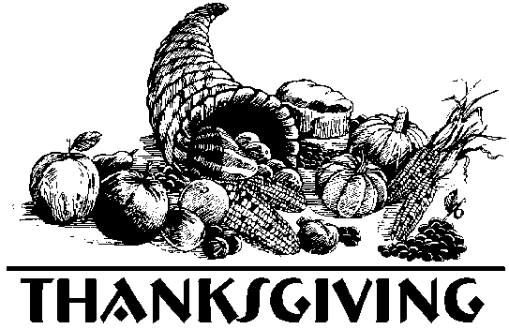

SERVICE

Wednesday, November 23, 2022
6:00 P.M.

Please join us on Wednesday evening, November 23rd at 6:00 p.m. as we give thanks to our Gracious God for the cornucopia of spiritual fruit that we share with one another – love, joy, peace, patience, kindness, goodness, faithfulness, gentleness, and self-control.

******* We will be collecting canned goods and other non-perishable items to donate to our local food pantry on Thanksgiving Eve. Please share what you can.



Don’t forget to turn your clocks back when you go to bed on November 5th! Daylight savings time ends on November 6th. Enjoy the extra hour of sleep and then come see us at church and Sunday.

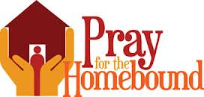

Fern Dubs  2423 Smith Road  Bay Port, MI 48720  (989) 453-2959 | Don Fibranz  Satchell’s Christian  Foster Care Home  2662 E. Caro Road  Caro, MI 48723
Mabel Kain  Scheurer Hospital  Long Term Care  Room 55  Pigeon, MI 48755  (989) 453-3374 | Beverly Liedke  160 Country Bay Drive  Room 308  Pigeon, MI 48755  (989) 453-3637
 | Bonnie Nowaczyk  7305 Main Street  Owendale, MI 48754  (989) 553-4286 or  (989) 678-4286

Keep them in your prayers, maybe give them a call and/or to visit them.


The deadline for the November issue of St. Paul’s “Epistle” will be Sunday, November 20, 2022. You can email them to Sandy at salcido.sandy8@gmail.com

Nov. 2 – Eric Wissner
3 – Dean Deering
3 – Tiffany O’Hare
4 – Tiffany Murphy
4 – Cody Howard
5 – Olivia Dyer
7 – Travis Deering
8 – Kevin Truemner
8 – Matthew Ricker
12 – Tracy Schaper
12 – Connor Timmons
13 – Myrna Born
15 – Melissa Gilbert
16 – Tristan Deming
16 – Melissa Witkovsky
16 – Jylan Shope
20 – Clinton Shope

20 – Megan Schaper
20 – Riley Richmond
21 – Emily Dubs
23 – Connor Ewald
24 – Brianna Fritz
24 – Kendal Truemner
25 – Walter Haag
27 – Amanda Gettel
27 – Jeffrey Dubs
30 – Ashley Hiles
30 – Dianna Dubs



Nov. 3 – Richard & Beverly Wise
4 – Lee & Janet Truemner
6 – Pastor & Kristen Suggitt
21 – Kendal & Rose Truemner
22 – Gerald & Angela Dubs
24 – Gerald & Bonnie Nowaczyk
IN HIS SERVICE


Nov. 6 – Ron Tabar & Robert Haag
Nov. 13 – Marc Reinhardt & Josh Sprague
Nov. 20 –
Nov. 23 (Thanksgiving Eve) –
Nov. 27 –

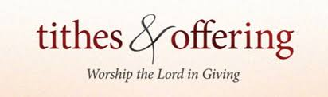
Nov. 6 – Patti Reinhardt & Kari Ricker
Nov. 20 – Liz Reehl & Kim Krohn

Lucille Welchner
Kristen Suggitt


Nov. 6 – Charlie & Margaret Timmons
Nov. 13 – Dick & Lucille Welchner
Nov. 20 – Norbert & Liz Reehl and Girls
Nov. 27 – Joyce Metzge


Margaret Timmons
Tammy Timmons

November

Sun | Mon | Tue | Wed | Thu | Fri | Sat
 |  | 1  6:15 PM  Elders  7:00 PM  Council | 2 | 3  6:30 PM  Bible Study | 4 | 5
6  8:30 AM  Service  9:30 AM  SS & Coffee Hr.  Ladies Aid Mtg.  1:30 PM  Catechism  3:30 PM  Adult Catechesis | 7 | 8 | 9 | 10  6:30 PM  Bible Study | 11 | 12
13  8:30 AM  Service  9:30 AM  SS & Coffee Hr.  1:30 PM  Catechism  3:30 PM  Adult Catechesis | 14 | 15 | 16 | 17  6:30 PM  Bible Study | 18 | 19
20  8:30 AM  Service  9:30 AM  SS & Coffee Hr.  1:30 PM  Catechism  3:30 PM  Adult Catechesis | 21 | 22 | 23  6:00 PM  Thanksgiving  Eve Service  Food Pantry Donations | 24  Thanksgiving  Day   | 25 | 26
27  8:30 AM  Service  No SS or  Catechism  3:30 PM  Adult Catechesis | 28 | 29 | 30  7:00 PM  Mid-Week Advent  @  Good Shepherd | 2022


St. Paul's "Epistles"
St. Paul Evangelical
Lutheran Church
7292 Kilmanagh Rd.
Pigeon, MI 48755

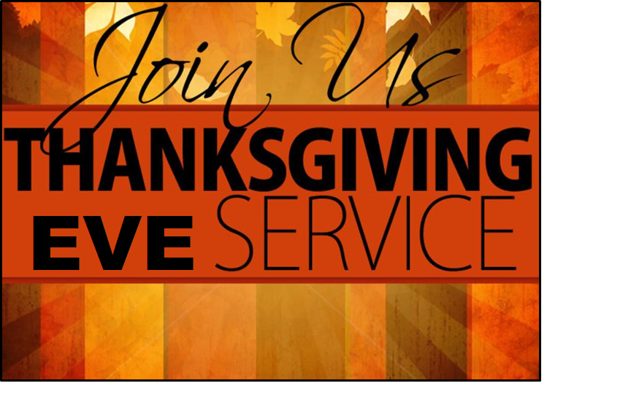
Wednesday, November 24, 2021
6:00 p.m.

