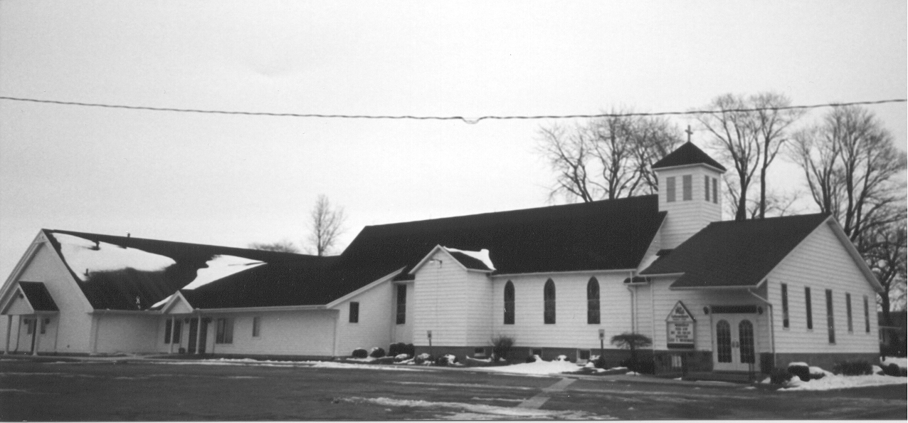 St. Paul's
" E p i s t l e s" July / August 2026 Volume 42 No. 9

The counsel of the Lord stands forever, the plans of his heart to all generations. Blessed is the nation whose God is the Lord. Psalm 33:11-12

Our red, white, and blue flag hangs on front porches. A beautiful stars and stripes bunting is draped on fences and railings. 250 years of our beautiful country is being celebrated all over the place. Even with all her imperfections, she’s our country. We’ve been afforded many opportunities and freedoms that others envy and even relocate for. Others who came before us have entrusted her to our care that more generations would have opportunities and freedoms. It’s a great thing to celebrate.

Some have given their lives for what we now enjoy. They believed it was worth it. And it is. Think of what we are able to do and enjoy. Want to go to church and not be afraid to live the Christian faith in public? Done. You can do it. Want to talk about Jesus with your neighbor or co-worker? You’re free to do it. How many places in the world is it oh so different? Many. Christians having to secretly gather or watch what they say lest they be persecuted, jailed, or worse. Not us. To be sure, there are battles happening. There are cake makers, sidewalk counselors, athletes in June, prayer circles on high school football fields in the fall - all feeling pressure or coercion to change their ways to the ways of the world. But here’s the thing in our country: we are free to rally around them to support and encourage them. We have the freedom to be bold and not shy away from the good and true things our Lord has given us. She may not be perfect, yet even with all her warts and blemishes, our country is still the best place to live.

Don’t take it lightly: use your freedom. Thank God for it and use it to raise your family in the Christian faith and bring them to church. Use it to openly have a Bible in your home which you read and share with others. Use it to speak the truth of God’s revealed will and encourage your brothers and sisters who may face trouble because of it. Others who came before us fought and prayed for this freedom and God has given and made you an inheritor of it. While we adorn our homes with red, white, and blue, let us more so adorn our homes with God’s Word and promises. May He continue to bless us and our country! 250 years! O Lord, let your Gospel have free course in the land that we love!

God bless our native land;
Firm may she ever stand
Through storm and night.
When the wild tempests rave,
Ruler of wind and wave,
Do Thou our country save
By Thy great might.
(LSB 965:1)

Happy 4th of July!
In Christ,

Pastor Suggitt
Vacation Bible School @ St. Paul

Jesus Comes to Seek & Save

Our Vacation Bible School week was a wonderful success as we learned how Jesus seeks and saves. Throughout the week, 18 children attended and enjoyed learning God’s Word through stories, music, crafts, games, and fellowship. On Monday, we learned how God saved baby Moses; Tuesday focused on Zacchaeus; Wednesday celebrated that Jesus rose from the dead; and we ended the week learning how Jesus saved Paul.

We were blessed with many generous meals provided during the week—Monday the Council cooked hot dogs with mac & cheese; Tuesday Brandy Gunsell prepared spaghetti; Wednesday the Ladies Aid hosted a breakfast for the children, and Thursday Sunday School donated pizza.

Our youth group truly stepped up this year and did an amazing job helping. Kolbie Holland and Silver Sprague taught preschool through first grade; Dallas Holland and Jackson Rosenthal helped with recess; Paige Howard and Addison Talaski led crafts. Grace Suggit did a fantastic job with music; and Pastor Suggit guided us each day with opening and closing. We also want to thank the ladies who faithfully came each day to help wherever needed.

Our offering supported Sunday school materials for children in Southeast Asia, allowing us to purchase 110 books with a total of $550 raised. We are so grateful to everyone who helped make this week meaningful and memorable. It was a true joy to see God at work as we shared the message of how Jesus seeks and saves.

Paula Holland, VBS Coordinator


Don Fibranz  Satchell’s Christian  Foster Care Home  2662 E. Caro Road  Caro, MI 48723 | Peggy Kelly  6282 Pine Street  Cass City, MI 48726  (989) 872-5086
Bonnie Nowaczyk  7305 Main Street  Owendale, MI 48754  (989) 553-4286 or  (989) 678-4286 | Dennis Schweitzer  2875 Shebeon Road  Sebewaing, MI 48759  (989) 883-9197
Lola Stein  8901 Geiger Road  Pigeon, MI 48755  (989) 453-2051 | Jeannine Ziehm  c/o Jennifer Scott  5318 Indian Trail  Ypsilanti, MI 48197



The deadline for articles for the September issue of St. Paul’s “Epistle” is Sunday, August 23, 2026. You can email them to Sandy at salcido.sandy8@gmail.com.

Thanks for keeping us informed about what’s going on at St. Paul.
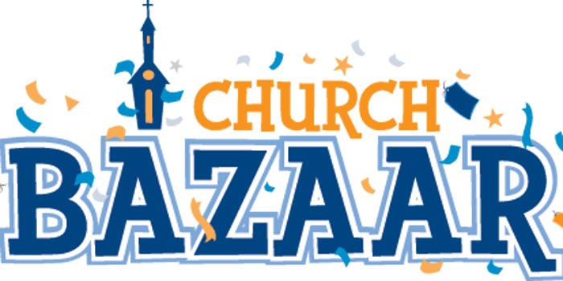

October 17, 2026
10:00 a.m.

The church bazaar is scheduled for Saturday, October 17th. What will you and your family do to help make it a success? We need lots of crafts, canned goods, extra produce, lots of baked goods. Let’s get everyone involved!

A group of volunteers have been busy working on baskets for the bazaar. We’ve begun collecting items for White Elephant Sale. Gardens are growing, so hopefully you’ve been planning what you will be canning for the bazaar.

If you’d like to donate but aren’t sure what to contribute, consider teaming up with a friend or neighbor to create a themed basket, or bringing a favorite family recipe to share in the bake sale. Remember, little hands can help too—children’s crafts or simple baked goods are always a hit with visitors.

Let’s also not forget about the importance of spreading the word. Tell your friends, colleagues, and community groups about the bazaar, and invite them to join us for a day of fun and fellowship. With everyone’s generosity and enthusiasm, this year’s bazaar is sure to be a memorable event for all!
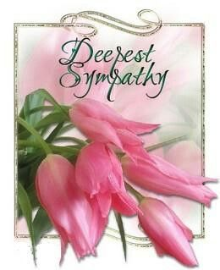
- Linda Ardell Schweitzer passed away Friday, May 22, 2026. She was given Christian burial on May 26, 2026.

The Lord gives and the Lord takes away; blessed be the name of the Lord.

- On Monday, June 8, 2026, Wilma Catherine Kovach fell asleep in Jesus. She was given Christian burial from St. Paul on Friday June 12, 2026.

Please keep their families and friends in your prayers for peace to bring comfort, courage to face the days ahead, and loving memories to forever hold in their hearts.

St. Paul's "Epistles" is published monthly by St. Paul Evangelical Lutheran Church, 7292 Kilmanagh Road, Pigeon, MI, 48755.

Pastor: Rev. Christopher Suggitt

Church & Office Phone: (989) 453-2271
Pastor Suggitt’s Cell Phone: (989) 551-3976

Church Email: lvlspaul40@gmail.com
Secretary’s Email: salcido.sandy8@gmail.com

Sunday Worship: 8:30 a.m.
Sunday School: 9:30 a.m.
Catechism: 1:30 p.m.

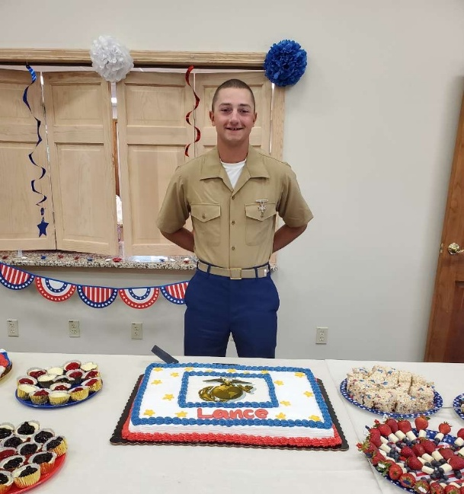

Welcome Home, Lance
On Sunday, June 21, a special Coffee Hour was held in the fellowship hall to welcome Lance Deming home from basic training and celebrate his becoming a Marine.
Thank You
Thank you to everyone who attended Lance’s reception. It was wonderful to see so many members of the congregation dressed in red, white, and blue to show their support.
Gratitude and Prayers
Lance and his family sincerely appreciate the thoughts and prayers offered during his time at basic training and ask for continued prayers as he begins this next chapter.

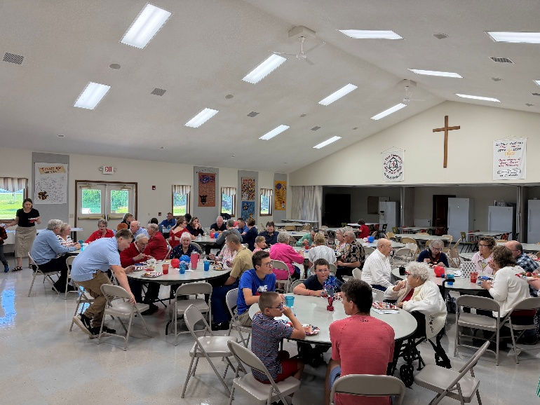
The Lutheran Hour is heard Locally on WLEW Bad Axe at 11:10am Sundays and WSAM 1440 Saginaw at 8:30 a.m. Sundays. OR listen to it anytime anywhere on the Lutheran hour APP on your phone. Download the Lutheran Hour Devotions app and click on Lutheran hour sermons. You can also find the Lutheran hour sermons on the Lutheran hour website at lhm.org. You can also dial 1-800-944-3450 and you will get the recorded instructions. Hit 3 then 1 and the whole Lutheran hour sermon will play just like you are receiving a phone call.

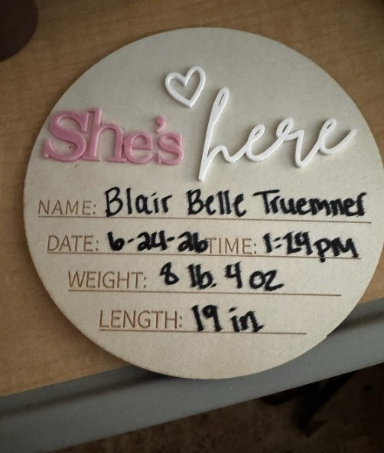

Sugar & Spice & Everything Nice

Daughter of Kyle Truemner & Jamie Webber
Granddaughter of Kevin & Sheila Truemner
Great Granddaughter of the late Lee & Janet Truemner
HOW DO YOU RECEIVE YOUR NEWSLETTER?

Church mailbox?

Snail mail?

Email?

Well, guess what? The US Postal Service is going to raise the cost of a first-class postage stamp AGAIN! The cost of copy paper to print the newsletter is rising. So, here’s something to think about –

- Are you willing to retrieve your newsletter from your church mailbox?

- Would you be interested in having it delivered via email?

If you’re interested in receiving your newsletter via email or in your church mailbox, drop me a note on the desk in the church office and I’ll make the change. Thanks.





These Food Pantry items are always welcome. Place them in the totes under the cost rack. Thanks for helping.

Crackers
Cereal
Pancake mix
Pancake syrup
Canned vegetables
Canned fruit
Canned fruit juice
Peanut Butter
Jelly
Ketchup
Mustard
Canned SpaghettiOs
Canned ravioli
Canned tuna
Boxes macaroni & cheese
Macaroni
Spaghetti
Spaghetti sauce
Canned beans
Ramen noodles
Toilet paper
Paper towels
Laundry detergent
Dish detergent
Shampoo
Conditioner
Toothpaste

IN HIS SERVICE

JULY ELDERS
July 5 – Robert Haag & Josh Sprague
July 12 – Ron Tabar & Matt Reibling
July 19 – Joe Salcido & Ken Haley
July 26 – Robert Haag & Josh Sprague

JULY ACOLYTES
July 5 – Harold Haag
July 12 – Brettly Ewald
July 19 – Silver Sprague
July 26 – Saige Ondrajka

JULY GREETERS
July 5 – Brandy Gunsell
July 12 – Joyce Metzger
July 19 – Rich & Ruth Fluegge
Jully 26 – Jeramy, Melissa, & Tristan Deming

JULY TITHE COUNTERS
July 12 – Liz Reehl & Kim Krohn
July 26 – Jen Timmons & Brandy Gunsell

JULY ALTAR GUILD & ALTAR FLOWERS
Wendy Tabar 989-977-1537
Faye Errer 989-678-4105

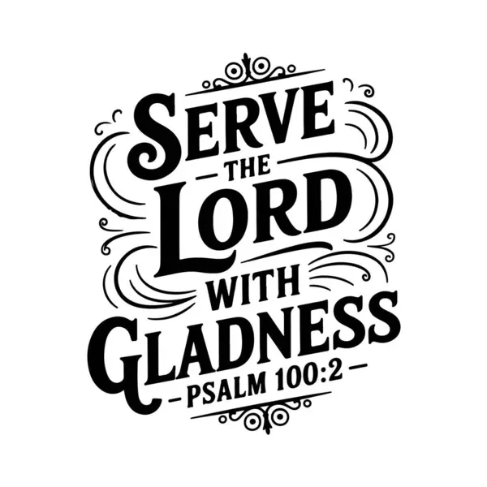

IN HIS SERVICE

AUGUST ELDERS
August 2 – Joe Salcido & Matt Reibling
August 9 – Ken Haley & Robert Haag
August 16 – Ron Tabar & Josh Sprague
August 23 – Joe Salcido & Matt Reibling
August 30 – Ken Haley & Robert Haag

AUGUST ACOLYTES
August 2 – Lincoln Ewald
August 9 – Harold Haag
August 16 – Brettly Ewald
August 23 – Silver Sprague
August 30 – Saige Ondrajka

AUGUST GREETERS
August 2 – Dale Kundinger, Laura Swartzendruber and Kids
August 9 – Kari Ricker
August 16 – Charlie & Margaret Timmons
August 23 – Chad & Jen Timmons
August 30 – Jason & Patti Reinhardt

AUGUST TITHE COUNTERS
August 9 – Patti Reinhardt & Kari Ricker
August 23 – Jylan Shope & Chris Gettel

AUGUST ALTAR GUILD & ALTAR FLOWERS
Wanda Dubs 989-550-3885
Jan Stoeckle 989-670-0702

July 1 – Archie Carlisle
2 – Anna Haag
2 – Todd Murphy
4 – Gage Metzger
4 – Pastor Lee Wenskay
5 – Richard Welchner
7 – Patrick Fritz
11 – Katelyn Dubs
12 – Joshua Seibel
13 – Allen Roe
14 – Kolbie Holland
14 – Joell Wissner
15 – Jeannine Ziehm
15 – Kristen Suggitt
16 – Dennis Dubs
16 – Tristin Bruce
17 – Nichole Nowaczyk
24 – Sharyn Rockefeller
25 – Stephen Rockefeller
27 – Dylan Dubs
29 – Annette Prich
29 – Wanda Dubs
31 – Joyce Metzger
31 – Katelyn Romzek


July 2 – Ron & Diana Dubs
5 – Matt & Michelle Reibling
10 – Derrick & Paula Holland
31 – Shawn & Laura Swartzendruber

Aug. 3 – Chris Gettel
3 – Jacob O’Hare
4 – Michelle Murphy
5 – Richard Renn Sr.
5 – Chase Swartzendruber
7 – Benjamin Engelhardt
7 – Noah Osantoski
8 – Brandy Gunsell
11 – Derek Ricker
11 – Justin Dubs
12 – Don Parrish
12 – Jerold Stein
13 – Ruth Fluegge
13 – Kaylee Krohn
14 – Garry McKellar
15 – Adam Reinhardt
17 – Gerald Dubs
19 – Jeremy Jamieson
19 – Tiffany Jamieson
19 – Joe Salcido, Jr.
19 – Kevin Dubs
19 – Lacie Prich
22 – Rich Witkovsky
25 – Paula Holland
26 – Jeffrey Kovach
26 – Pastor Suggitt
27 – Jane Schuette
27 – Laura Toner
27 – Jennifer Timmons
28 – Larry Prich
29 – Chris Tabar
30 – Madison Renn
30 – Kaitlynn Stein
31 – Deborah Ziehm

AUGUST ANNIVERSARIES

Aug. 8 – David & Hope Gilbert
15 – Charles & Margaret Timmons
25 – Jason & Patti Reinhardt

Sun  July | Mon | Tue | Wed | Thu | Fri | Sat
 |  |  | 1  6:30 PM  Bible Study | 2 | 3 | 4
5  8:30 AM  Service | 6  Pastor on Vacation | 7  6:15 PM  Elders  7:00 PM  Council  Pastor on Vacation | 8  No  Bible Study  Pastor on Vacation | 9  Pastor on Vacation | 10  Pastor on  Vacation | 11  Pastor on  Vacation
12  8:30 AM  Service  Pastor on Vacation | 13  Pastor on Vacation | 14  Pastor on Vacation | 15  No  Bible Study  Pastor on Vacation | 17 | 18 | 19
20  8:30 AM  Service | 21 | 22 | 23  6:30 PM  Bible Study | 24 | 25 | 26
27  8:30 AM  Service | 28 | 29 | 30  6:30 PM  Bible Study | 31  2026

Sun  August | Mon | Tue | Wed | Thu | Fri | Sat
 |  |  |  |  |  | 1
2  8:30 AM  Service | 3 | 4  6:15 PM  Elders  7:00 PM  Council | 5  6:30 PM  Bible Study | 6 | 7 | 8
9  8:30 AM  Service | 10 | 11 | 12  6:30 PM  Bible Study | 13 | 14 | 15
16  8:30 AM  Service | 17 | 18 | 19  6:30 PM  Bible Study | 20 | 21 | 22
23  8:30 AM  Service | 24 | 25 | 26  6:30 PM  Bible Study | 27 | 28 | 29
30  8:30 AM  Service | 31 |  |  |  | 2026

St. Paul's "Epistles"
St. Paul Evangelical
Lutheran Church
7292 Kilmanagh Rd.
Pigeon, MI 48755



Sunday @ 8:30 a.m.

